DSCT Core - 009 - Data Visualisation Using PowerBI

1. Access your PowerBI Service account using your CrimsonLogic email address and AD account password. Login to <http://powerbi.microsoft.com> and click on the Sign In link.

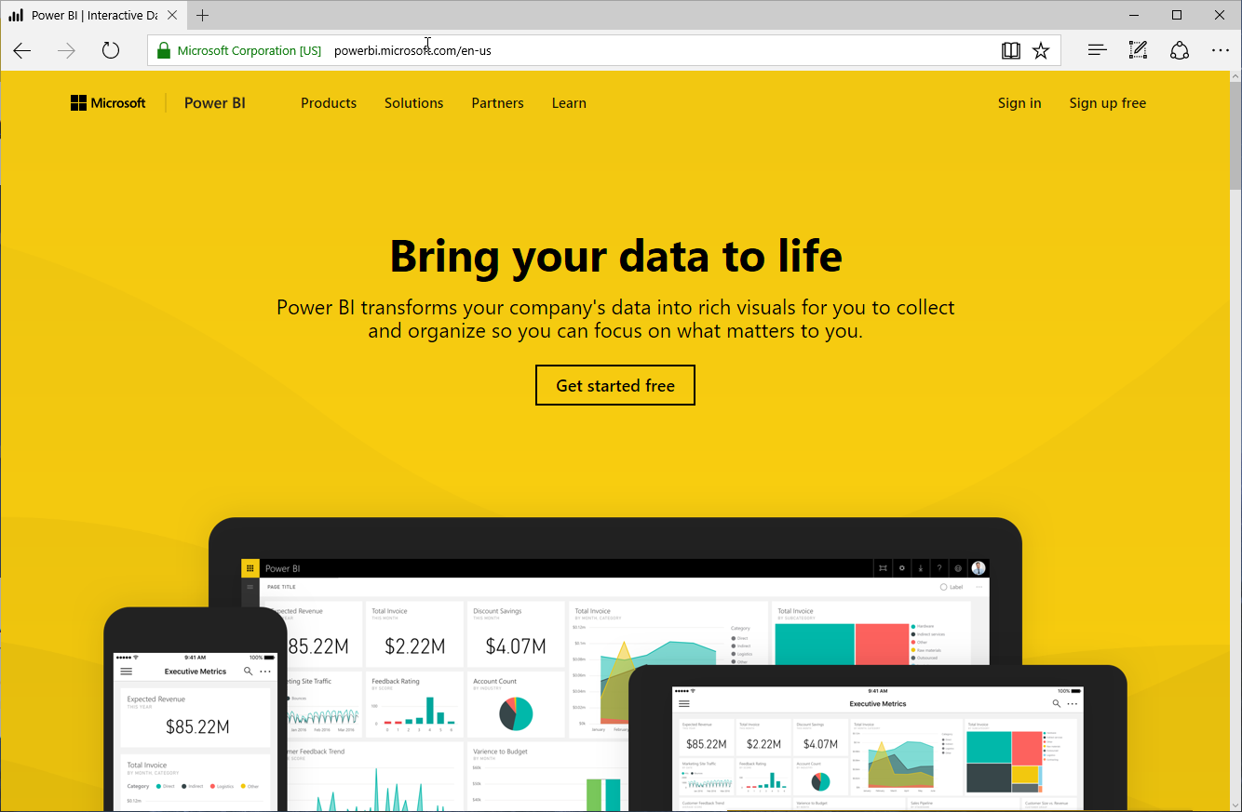

Login with your CrimsonLogic AD user ID and password when prompted with the organisation login page

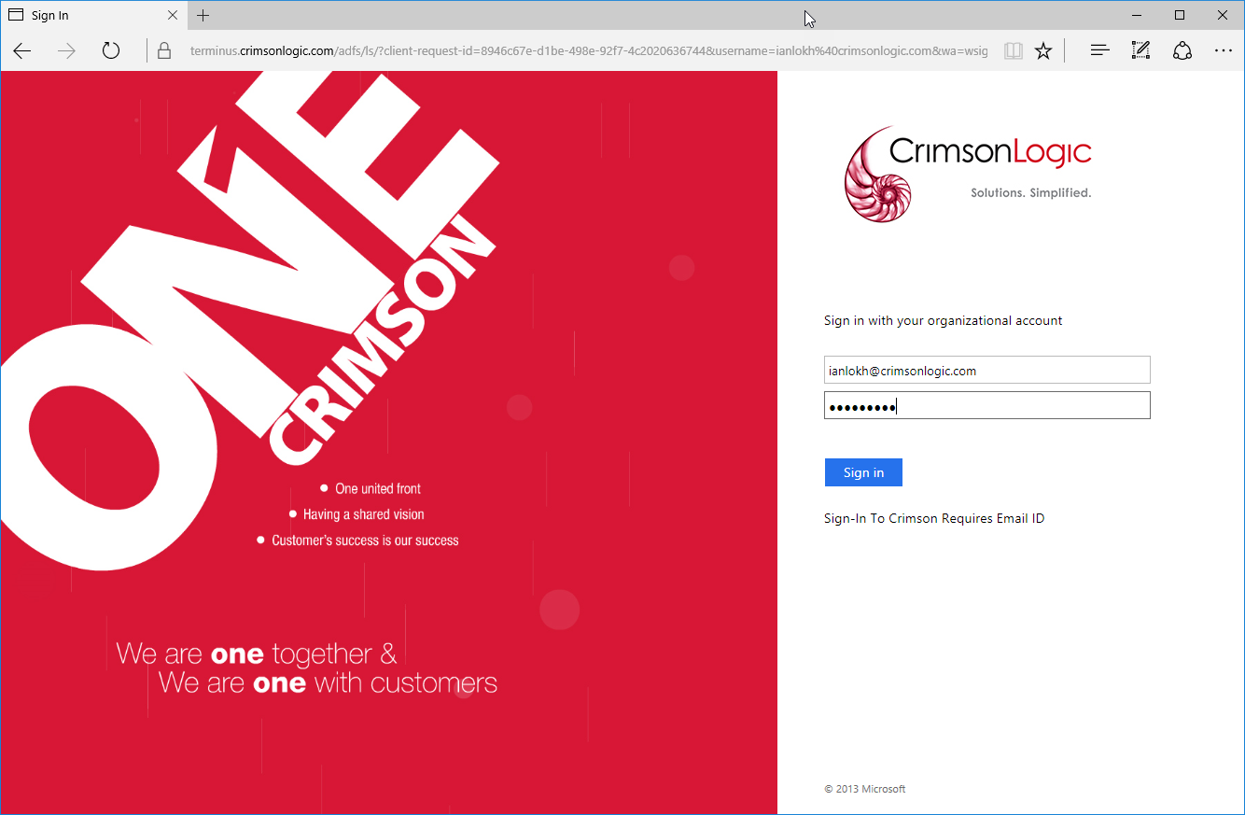

PowerBI Service screen will be shown as follows. This confirms the successful login to the PowerBI Service.

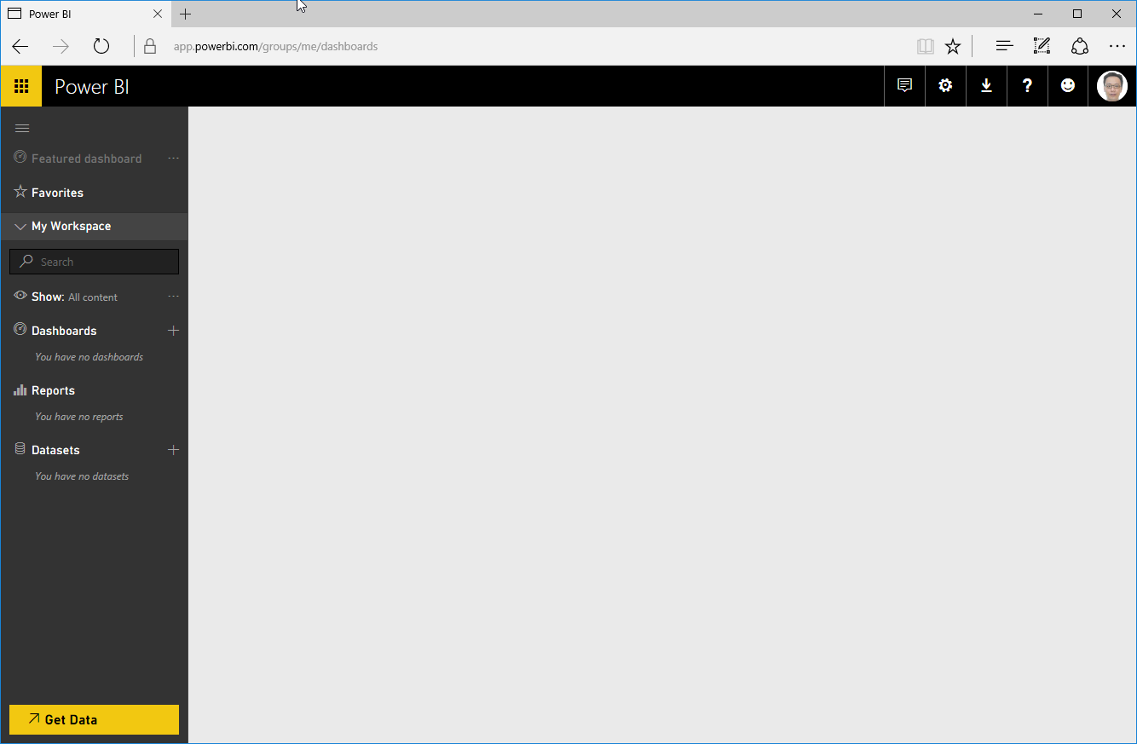

1. Install the latest version of PowerBI Desktop if you have not already done so. If PowerBI Desktop has been installed, launch the application.

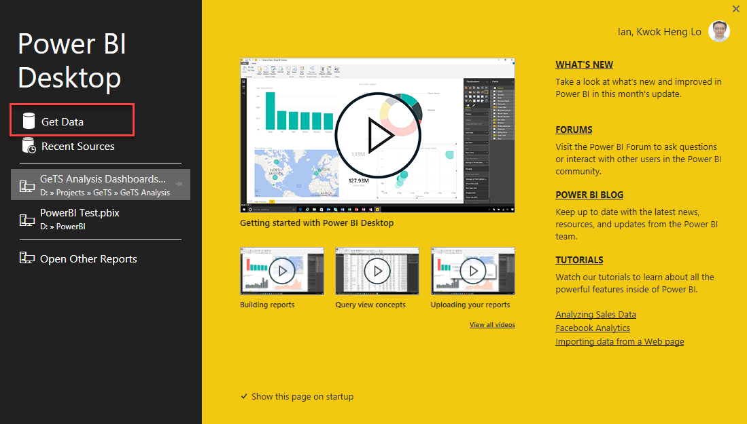

At the splash screen, click on Get Data to start importing the sample data for the report.

At the Get Data screen below, select Excel and click on the Connect button.

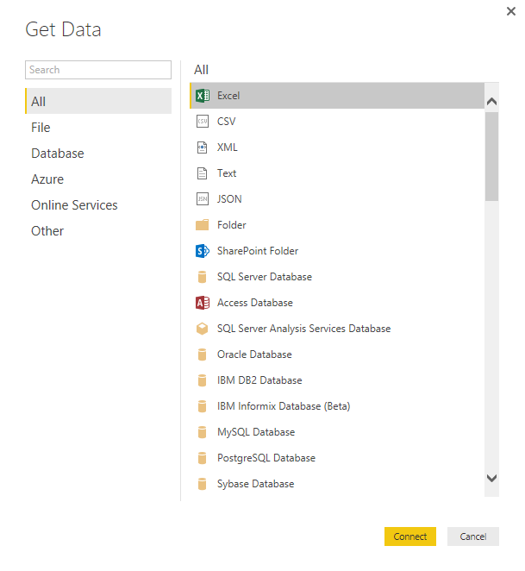 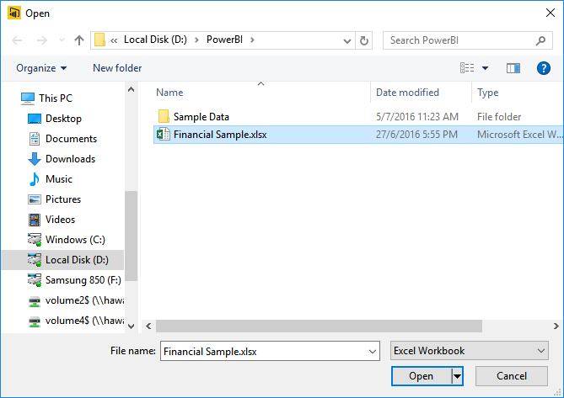

You will be prompted to select the xlsx file to import. Select the file Financial Sample.xlsx spreadsheet and click Open on the dialogue box.

Since the workbook has multiple sheets – select the sheet “financials”. A preview of the data to be imported will be shown. Click on the Load button to proceed to import the spreadsheet data.

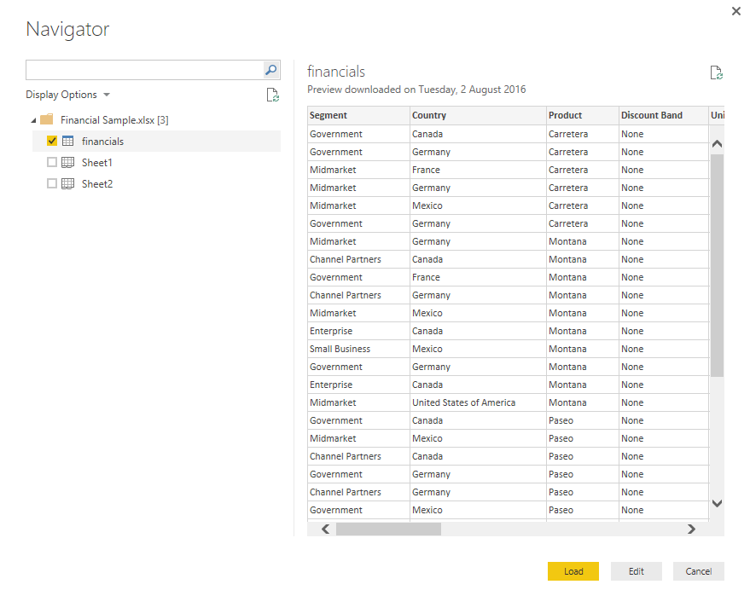

1. A blank canvas will be shown for you to start using visuals and creating a report. Click on the Text Box icon to create and position the following text

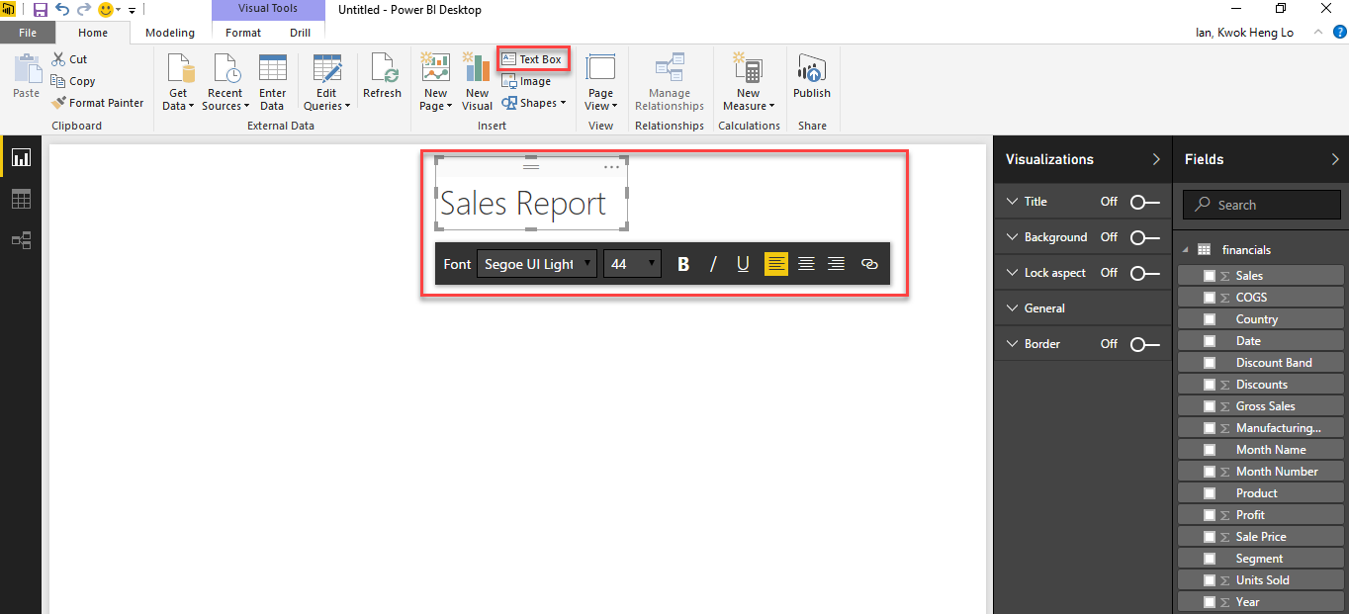

1. Next, create the following visuals:
   1. Total sales card
   2. Total sales by Segment horizontal bar chart
   3. Total sales by Country map

**Create the Total Sales Card Visual**

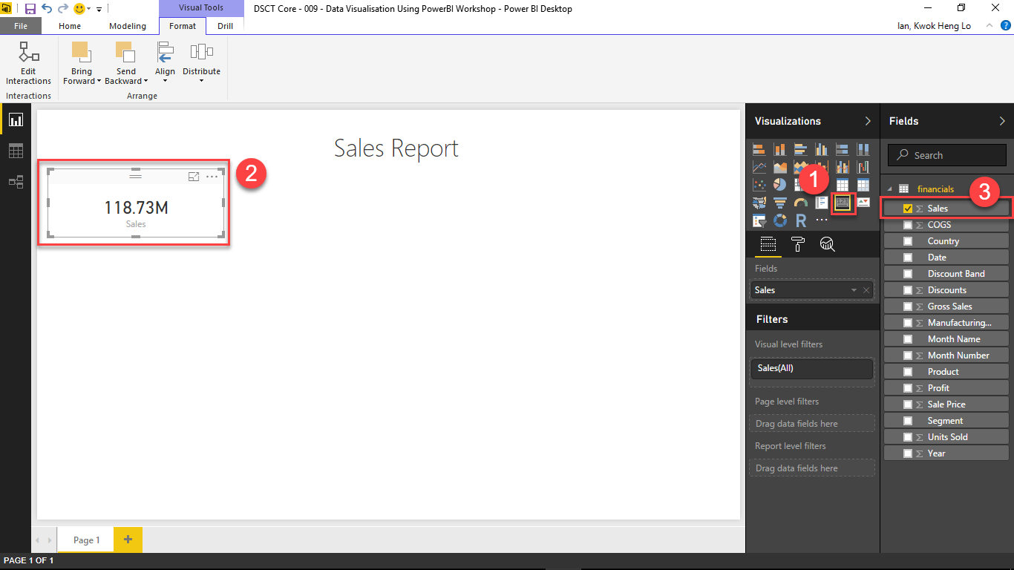

Update the font size of the Total Sales card

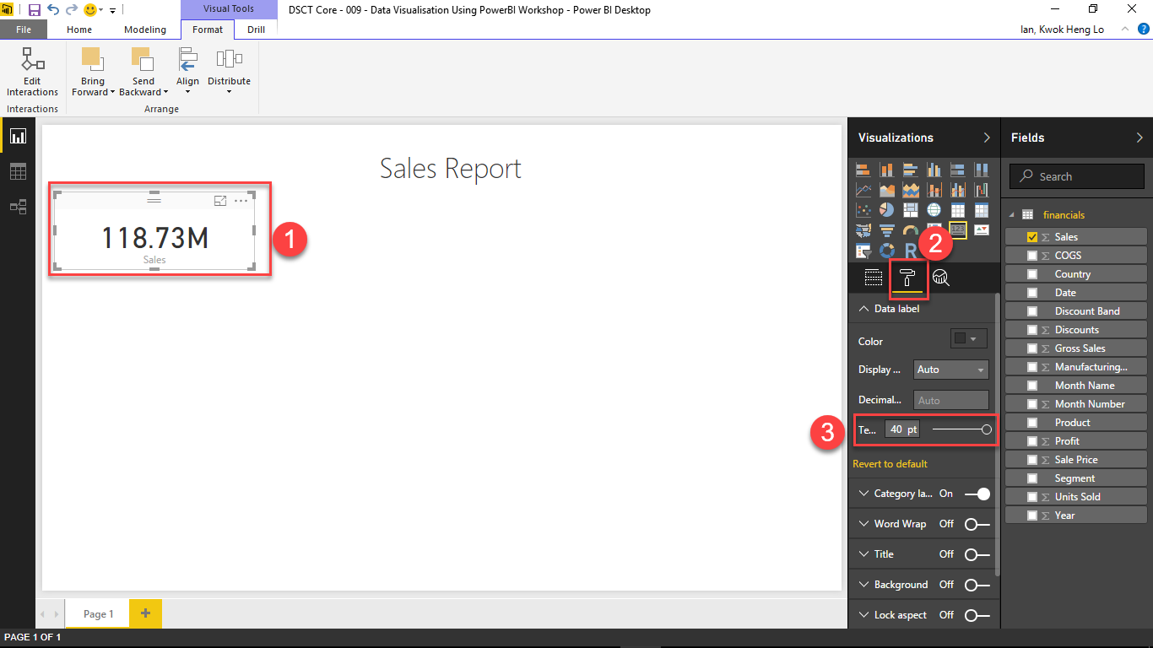

**Create the Total sales by Segment horizontal bar chart**

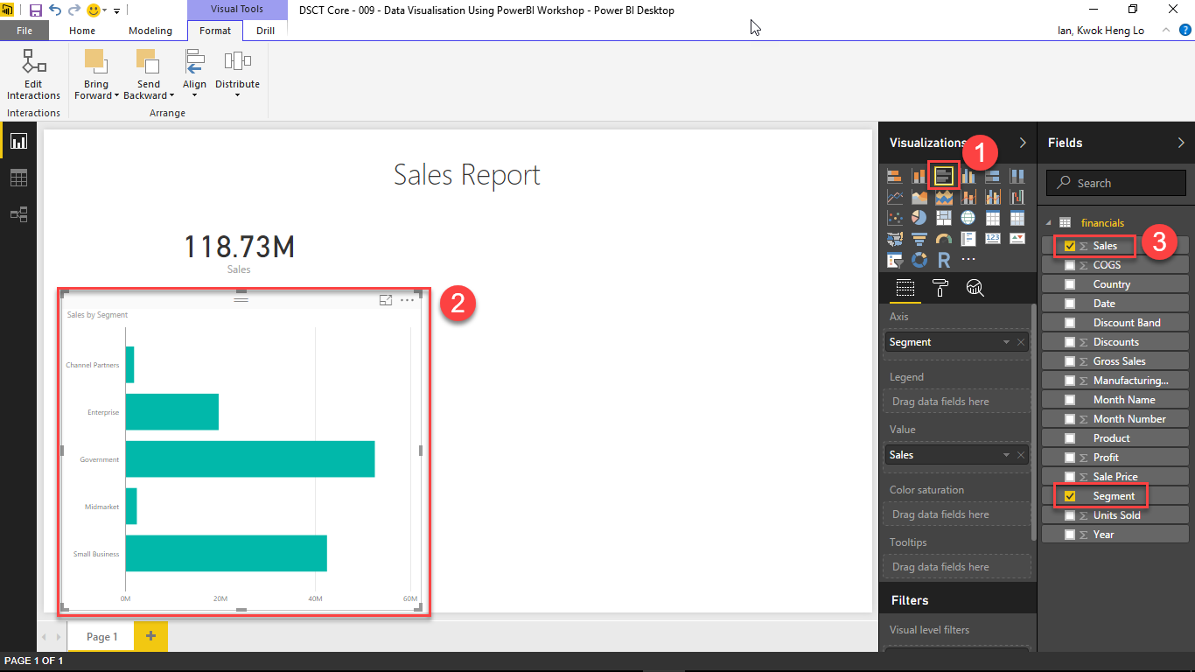

Update the font size of the Total Sales card

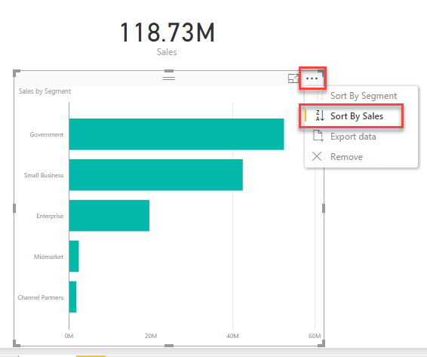

**Total sales by Country map**

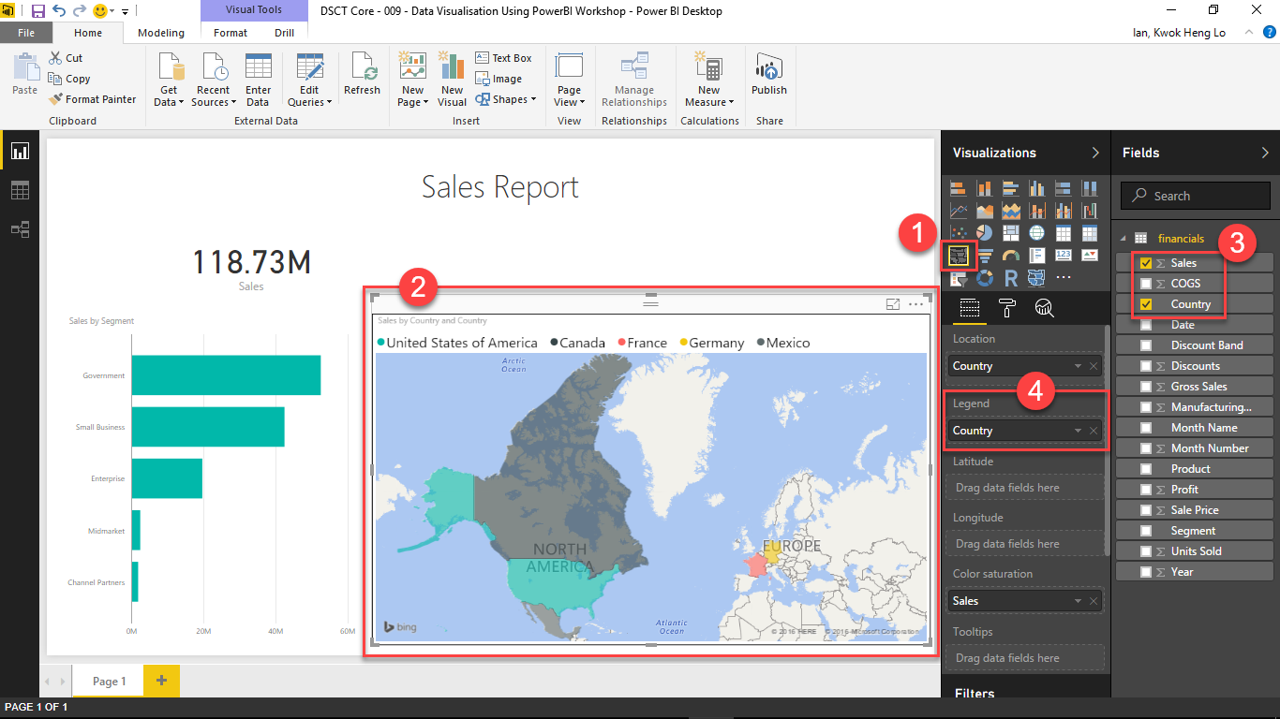

1. Publish the created report onto PowerBI Service by clicking on the Publish icon on the toolbar. Save your report if prompted to. To publish to the PowerBI Service, you need to be logged in from the PowerBI Desktop too.

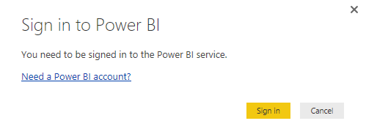

When prompted, click on the Sign In button and sign-in using your CrimsonLogic AD account.

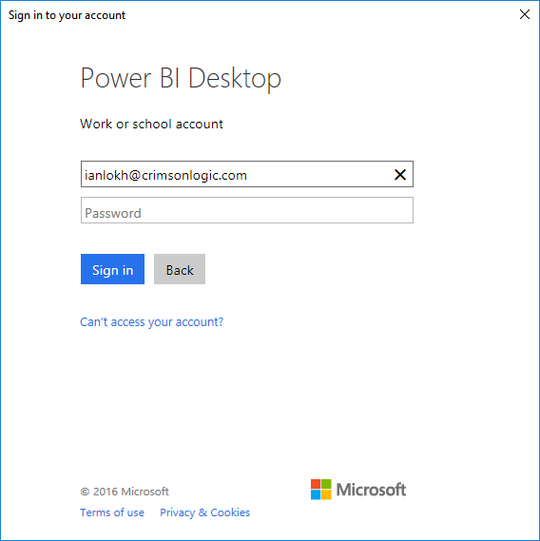 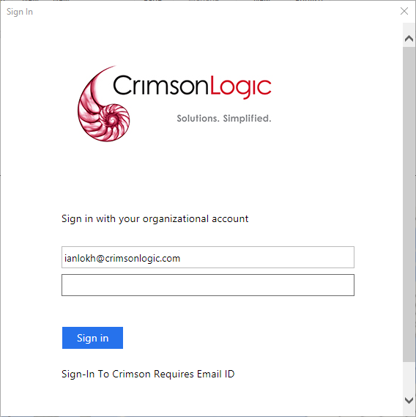

A confirmation dialog will appear once the report has been successfully published.

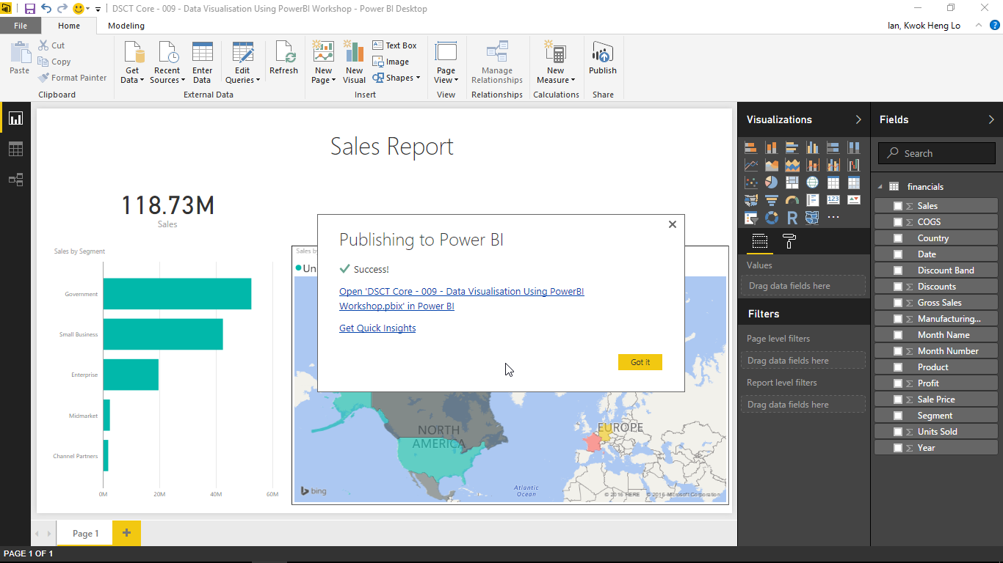

1. Login to PowerBI Service to view the report online. You should see the report you have just uploaded in the Reports menu. The Datasets menu will also contain the Excel data.

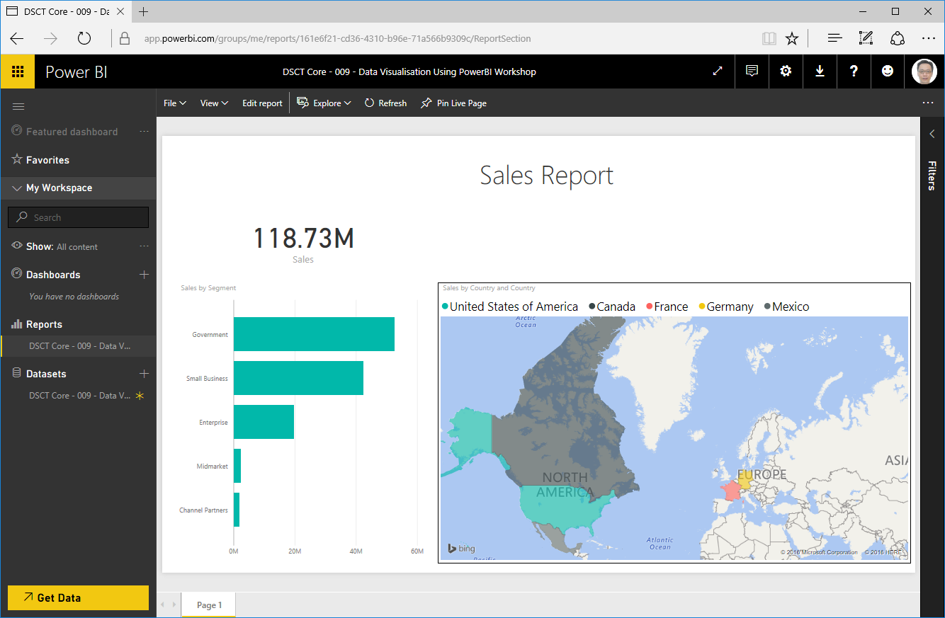

1. Click on the (+) next to the Dashboards menu to create a new dashboard – name it Sales Report Dashboard

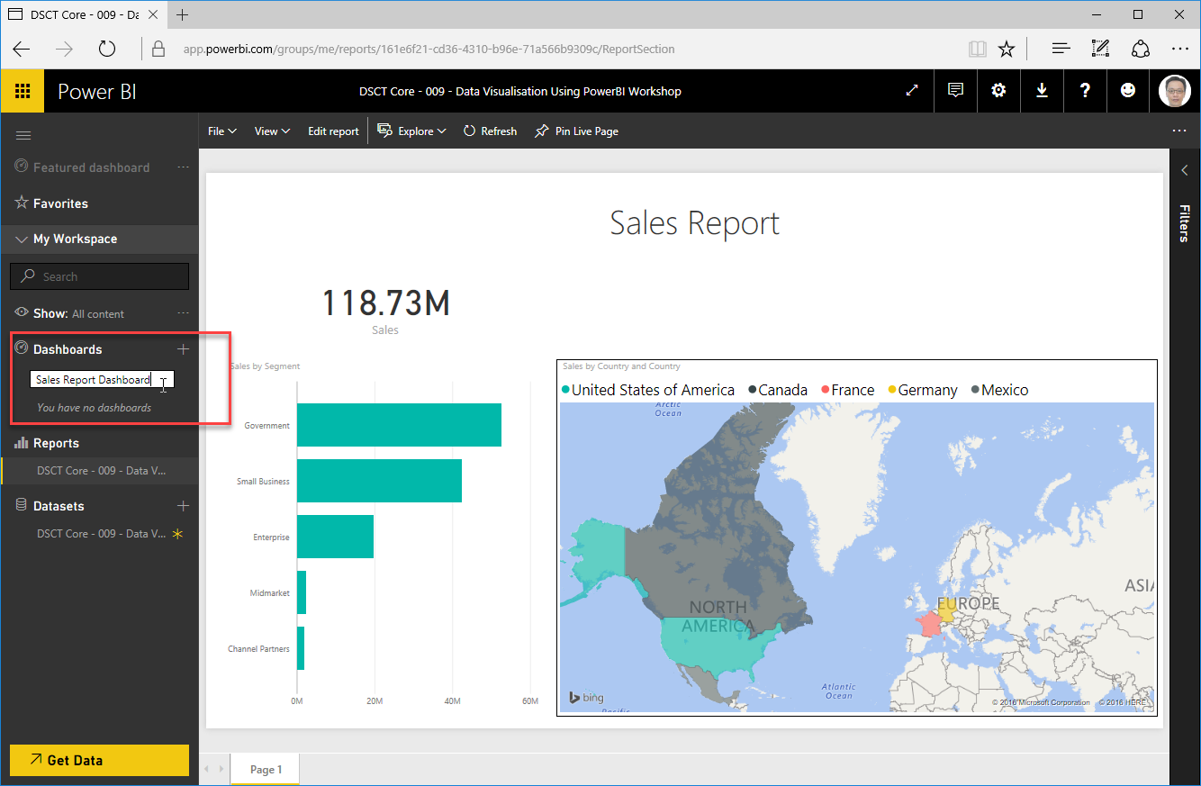

1. To add visuals from the report onto the Dashboard as tiles, navigate to the report under Reports mouse over the map to reveal a pin icon. Click on the pin icon and when the popup appears, select the Sales Report Dashboard. Click on Pin to pin the visual to the selected dashboard.

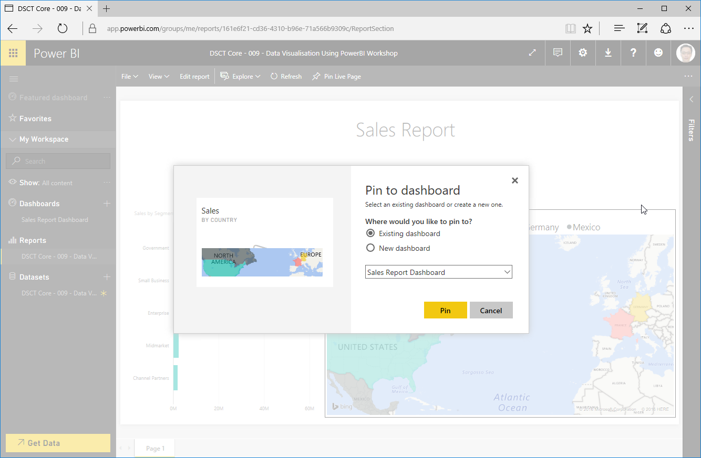

1. Click on the recently created dashboard to view the visuals previously pinned.

